**Experiment 34**

**AIM :**

To design NFA transition diagram of string n number of b’s in automata.

**Design and output:**

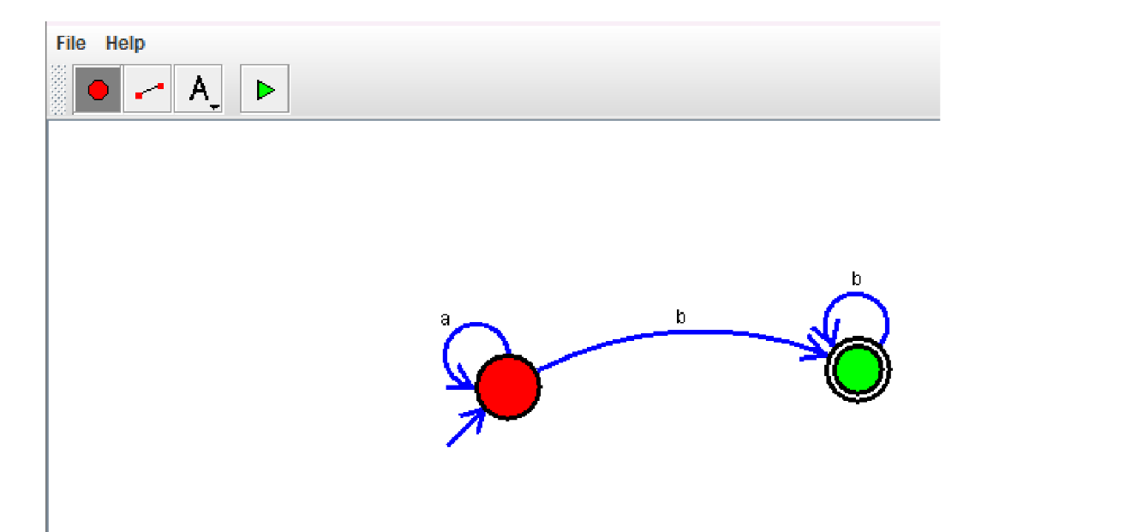

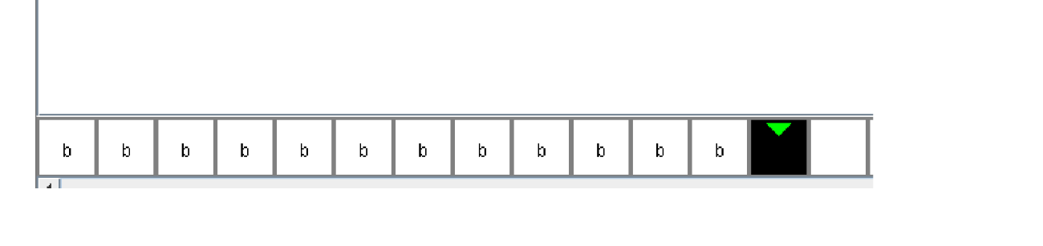

**Result:** Thus designing NFA transition diagram of string n number of b’s is done and verified by giving sample inputs.